Questions:

- Which algorithm is used for building models based on the decision tree?
- Explain feature selection using information gain/entropy technique?
- How do you decide a feature suitability when working with decision tree?
- What is Entropy?
- How are entropy and information gain related vis-a-vis decision trees?
- Why information Gain is important in Decision tree?
- Executing a binary classification tree algorithm is a simple task. But how does tree splitting take place? How does the tree determine which variable to break at the root node and which at its child nodes?

Answers:

- Which algorithm (packaged) is used for building models based on the decision tree?
Algorithm C5.0 is one of the most used implementations for building machine learning model based on the decision tree.

- Explain feature selection using information gain/entropy technique?
The goal of the feature selection while building a decision tree is to find features or attributes (decision nodes) which lead to split in children nodes whose combined entropy sums up to lower entropy than the entropy value of data segment before the split. This implies higher information gain.

- How do you decide a feature suitability when working with decision tree?
A decision node or a feature can be considered to be suitable or valid when the data split results in children nodes having data with higher homogeneity or lower entropy (weighted entropy of children nodes added to determine overall entropy after the split).

- What is Entropy?
Entropy can be defined as a measure of impurity of data. Higher the entropy, the higher impure the data is. It always lies between 0 to 1. The entropy of any split can be calculated by this formula.
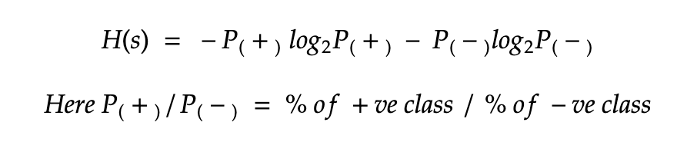

- How are entropy and information gain related vis-a-vis decision trees?
Information gain is the difference between the entropy of a data segment before the split and after the split. The high difference represents high information gain. Higher the difference implies the lower entropy of all data segments resulting from the split. Thus, the higher the difference, the higher the information gain, and better the feature used for the split.

- Why information Gain is important in Decision tree?
- Information gain is the main key that is used by Decision Tree Algorithms to construct a Decision Tree.
- Information gain (IG) measures how much “information” a feature gives us about the class.
- Decision Trees algorithm will always try to maximize Information gain.
- An attribute with highest Information gain will be tested/split first.

- Executing a binary classification tree algorithm is a simple task. But how does tree splitting take place? How does the tree determine which variable to break at the root node and which at its child nodes?
Gini index and Node Entropy assist the binary classification tree to make decisions. Basically, the tree algorithm determines the feasible feature that is used to distribute data into the most genuine child nodes.
According to the Gini index, if we arbitrarily pick a pair of objects from a group, then they should be of identical class and the probability for this event should be 1.
The following are the steps to compute the Gini index:
- Compute Gini for sub-nodes with the formula: The sum of the square of probability for success and failure (p^2 + q^2)
- Compute Gini for split by weighted Gini rate of every node of the split
Now, Entropy is the degree of indecency that is given by the following:
Where a and b are the probabilities of success and failure of the node
When Entropy = 0, the node is homogenous
When Entropy is high, both groups are present at 50–50 percent in the node.
Finally, to determine the suitability of the node as a root node, the entropy should be very low.

